Architecture Brief

AI Knowledge Platform – Architecture & Design

1. Soft Delete vs Hard Delete

Soft Delete (Default Approach)
Soft delete means the document is not physically removed from the database.
Instead:
- All chunks, embeddings, and uploaded files still remain in storage.
- It is safer and reversible.
- Accidentally deleted documents can be recovered easily.
- The document immediately disappears from search results because retrieval queries ignore deleted records.

Hard Delete
Hard delete permanently removes document record, chunks and embeddings
Hard delete is useful for permanent cleanup and reclaiming storage
It also delete embeddings first, then chunks, then the document to maintain database consistency

2. RAG Pipeline Design

Chunking Strategy

For code files:
It chunks based on functions, classes, logical code blocks.
If we split code randomly, functions break apart, meaning is lost and embeddings become poor. So we preserve entire functions/classes whenever possible.

For text/PDF/Markdown files
It uses fixed-size chunks with overlapping windows
Each chunk contains around 500 words and overlaps by ~50 words with the next chunk.
Overlap helps preserve context between chunks. Without overlap sentences may break in the middle and retrieval quality decreases
It also store metadata such as: whether the chunk is code or text and how it was split

Embedding Lifecycle
It uses the used all-MiniLM-L6-v2 model and generates 384-dimensional embeddings.
Document uploaded → Text extracted → Chunks created → All chunks embedded in batches → Embeddings stored in Postgres + pgvector

During query
- User query converted into embedding
- Similarity search performed against stored vectors

Similarity Search Approach
Used cosine similarity search directly inside PostgreSQL using pgvector
The database performs vector comparison, filtering, ranking in a single query. Giving faster retrieval and lower memory usage

Vector Database Choice
Chose PostgreSQL + pgvector instead of dedicated vector databases like Pinecone or Weaviate
1. Single datastore architecture
All data lives together documents, chunks, embeddings and logs. This avoids synchronization issues between separate databases.
2. Operational simplicity: This keeps deployment simple.
3. Scale requirements
For an internal AI knowledge platform, pgvector provides sufficient performance with much lower complexity.

Ranking / Reranking Strategy
Implemented a simple single-stage ranking approach where chunks are ranked directly using cosine similarity scores without any additional reranking model.
Adding rerankers:
- increases latency
- adds another ML model dependency
- increases infrastructure complexity
For current demo:
- ANN vector search already gives strong results
- keeping the pipeline lightweight was more important
The most relevant chunks are placed first inside the LLM prompt so the model sees higher-quality context earlier.

Failure Handling
Designed the system for graceful degradation. Instead of crashing completely, the system tries to remain usable. Introduced try-except exception handling to make the flow smooth
If ingestion fails:
- document status becomes FAILED
- failure is logged
- application continues running

3. Database Design

Indexing Strategy
Used HNSW vector index on embeddings, primary key indexes and foreign key indexes.
HNSW provides:
- fast approximate nearest neighbor search
- strong retrieval quality
- no training step required
Indexes allow fast top-k similarity retrieval.

Metadata Modeling
- Stored as relational columns – file type, status and timestamps
- Stored as JSON metadata – chunk type, split strategy and chunking details
Relational columns are fast for filtering and JSON metadata allows flexible schema evolution and avoids constant migrations

Query Patterns
The most common method is Vector similarity search + metadata filtering which includes:
- cosine similarity
- document status filtering
- deletion filtering
- top-k retrieval

Caching
We cache mainly over query function using LRU Cache property enabling the caching system over the queries but along with that we also cache using:
- embedding model
- OCR engine
- DB connections

Database Design and Schemas

Architecture Diagram

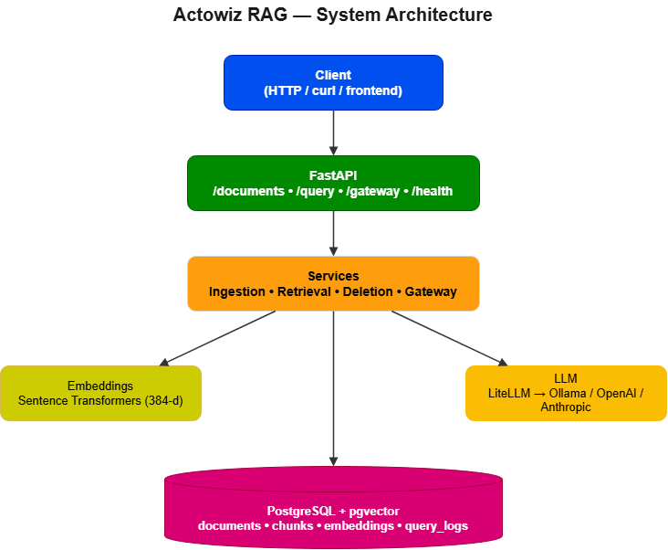

DataBase Schema

